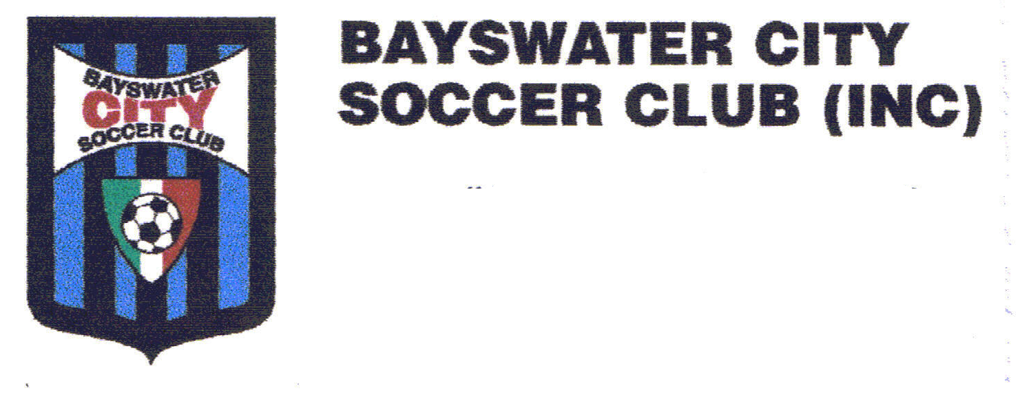
PLEASE WRITE CLEARLY

PLAYER REGISTRATION APPLICATION 2024 SEASON

PLAYERS SURNAME GIVEN NAMES

ADDRESS POSTCODE

DATE OF BIRTH AGE GROUP APPLIED FOR: (U6 - U18)

PARENT/GUARDIAN CONTACT DETAILS:

NAME : (M):

EMAIL: _________

SOCCER KIT SIZING - (circle one of each item)

Under 6 -7s – Fees $395 (non-refundable deposit $200)

SOCKS Size 2 Size 3

PLAYING SHORTS XXXS XXS XS S M L

POLO 6 8 10 12 14 S M L

TRAINING SHIRT XXXS XXS XS S M L

Under 8s – 18s – Fees (8-12) = $550 (non-refundable deposit $250) Fees (13-18) = $605 (non-refundable deposit $275)

SOCKS Size 2 Size 3

PLAYING SHORTS XXXS XXS XS S M L XL XXL

POLO 6 8 10 12 14 S M L XL XXL

TRAINING SHIRT XXXS XXS XS S M L XL XXL

TRACKSUIT JACKET XXXS XXS XS S M L XL XXL

PAYMENT DETAILS

Credit Card #_______________________________________________________

Name on Card_____________________________________________________

Expiry Date____________________ CSV______________(three digits)

OR DIRECT PAYMENT to
Bayswater City Soccer Club
BSB: 633-000
Account Number: 145490363
Reference: Your Child’s Surname and Age Group

PTO – Terms and conditions and Parent/Guardian Signing

